School leaver employment support
Provider reported services
July 2021 to June 2022

Market Innovation & Employment Branch
ndis.gov.au

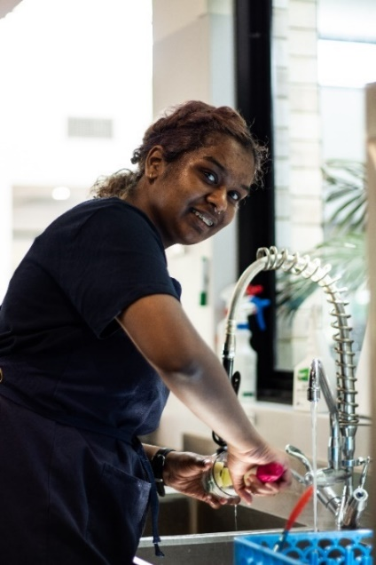
Priscilla’s story

Like many young people, 19-year-old Priscilla Ragesh wasn’t sure what she wanted to do when she was ready to leave school.
Priscilla, who embraces her Singaporean and Indian heritage, lives with an intellectual disability, which impacts her memory, learning and understanding.
“Sometimes I can’t remember long words and sometimes I find it difficult to read the (text) book and the questions, so I need to ask for help,” she says.
“School was up and down and friendship wise, it was challenging, it was difficult to make friends.”
Despite a sometimes-rocky road at school, Priscilla has many reasons to be smiling these days.
After leaving school, the Geelong teenager received specialised School Leaver Employment Supports, funded through the National Disability Insurance Scheme (NDIS).
The supports have led Priscilla to a positive new pathway in her life.
She has discovered a passion and a talent for working with children – and she’s getting paid for doing what she loves.
Priscilla now works 4 days a week at the Pipsqueaks Early Learning Centre and is also studying for formal childcare qualifications.
She does a range of jobs at work, including helping to set up the classroom and yard, and putting sunscreen on the children. She’s also enjoying teaching the kids how to say hello in Tamil.
“I discovered that I love working with kids,” Priscilla says. “We have a lot of fun together. They love it when we make silly faces and have a joke with them. They just laugh. I love playing ‘superhero’ with them.”
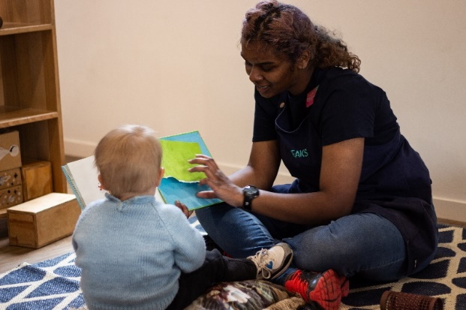
Priscilla’s supported employment journey was about exploring options, building skills, and finding work that would suit her best.
With the help of NDIS provider genU, Priscilla took part in an extensive ‘discovery’ process over 12 months.
She developed an action plan, which included goals to gain experience and find employment.
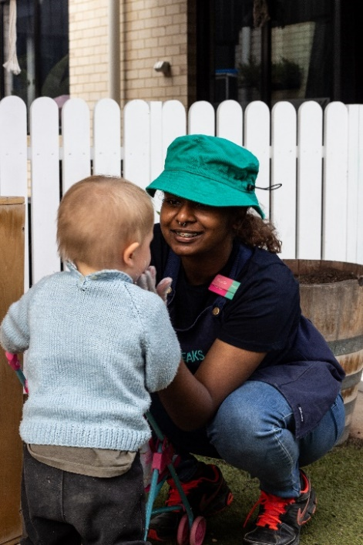
Priscilla took part in several work experience placements in the hospitality industry, which helped to build her general employment skills and knowledge.
She enjoyed learning kitchen hand, customer service and cleaning skills along the way.
This led to 2 days a week of paid employment as a kitchenhand at Pipsqueaks where genU provided Disability Awareness Training to staff.
Before long, Priscilla was a valued member of the team and realised she loved working with children.
“GenU helped to find and recommend me for the position with Pipsqueaks and the volunteering has given me some great experiences,” Priscilla says.
“My support workers have always been helpful and encouraging and I feel safe and respected by the staff at work.
“The supports have helped me gain more confidence and to start a different journey in my life.
“I’m happy I can be more independent and achieve what I want to achieve.”
Priscilla continues to be supported through the NDIS with funded employment supports. She receives ongoing mentoring and coaching to continue to build her skills. She also has help with her studies 2 days a week.
Priscilla is learning a range of soft employment skills, such as problem solving, and how to communicate with staff and customers.
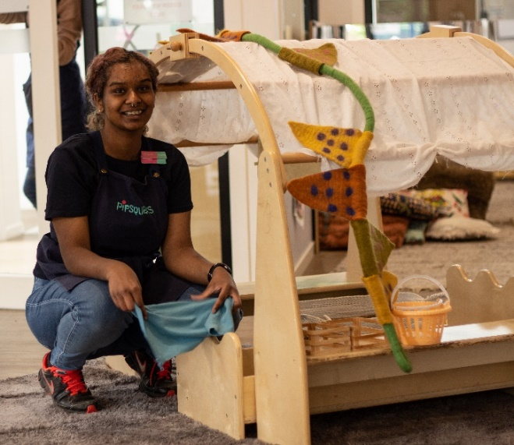
“All of these skills are important to ensuring Priscilla maintains her employment,” genU support worker Allison Strauch says.
Priscilla is proudly now at the tail end of a TAFE Certificate III in Childcare.
She says her new skills and confidence have also helped with making new friends.
“My life has changed a lot with the supports from the NDIS,” Priscilla says.
“I’m very happy, I feel a lot more confident in what I’m doing. I feel really happy because I can be with people, I feel comfortable with, and I can achieve what I want to achieve.
“I have new friends who I met at TAFE, and I’m really enjoying my life.”

Contents
School leaver employment support 1
Contents 4
1. Executive summary 6
1.1 Purpose 6
1.2 Employment support provider reporting 6
1.3 Report enhancements 7
1.4 Key findings 7
2. Provider and participant count 9
2.1 Provider count 9
2.2 Participant count 9
3. Participant demographics 10
3.1 Employment support recipients 10
3.2 Location 10
3.3 Primary disability 11
3.4 Age 11
3.5 Gender 11
3.6 Aboriginal or Torres Strait Islanders Status 12
3.7 Culturally and Linguistically Diverse status 12
4. Supports & milestones 13
4.1 Support type hours 13
4.2 Support delivery method 14
4.3 Progress towards milestones – snapshot at each reporting period 14
4.4 Progress towards milestones – cumulative for the year 17
5. Final outcomes 19
6. Final employment outcomes 22
6.1 Employment type 22
6.2 Hours worked 23
6.3 Industry of employment 24
6.4 NDIS supports in employment 25
6.5 Supported wages 25
7. Intermediate employment outcomes 26
7.1 Employment outcomes (July 2021 to June 2022) 26
7.2 Employment type 27
7.3 Hours worked 28
7.4 Industry of employment 29
7.5 NDIS supports in employment 30
7.6 Supported wages 30
8. Model summary 31
8.1 Modelling approach 31
8.2 What helps (or hinders) finding paid employment 32
8.3 Differences in modelling insights between reporting period ending Q4 (December) 2021 and Q2 (June) 2022 33
9. Appendix 34
9.1 Appendix 1 – Methodology for the section titled “Progress towards milestones – cumulative for the year” 34
9.2 Appendix 2 – Model accuracy 36

Executive summary

Purpose

We are committed to ensuring participants have the same opportunities to work as other Australians, and the confidence, support and skills to take advantage of those opportunities. Our goal is to have 30% of working age participants in meaningful employment by 30 June 2026. As at September 2022, 23% of working age participants were in paid employment. A key focus of the Agency is to improve the path between education to work for young participants.

School Leaver Employment Support is an early intervention support intended to smooth the transition from school to employment by building a young participant’s skills, confidence, and capacity for work.

A template for reporting employment outcomes for participants receiving “school leaver employment supports” was distributed to providers for completion from January 2021. The reports are completed at the end of each quarter and submitted to NDIA for collation and analysis.
The purpose of the report is to give visibility to the outcomes being achieved through school leaver employment funding. This allows providers to benchmark their own results against those for the sector as a whole. It also allows participants to request providers to advise their results and they can compare with whole of sector figures.
This report is the second edition and contains results for the 12 months July 2021 to June 2022. The first edition was for calendar year 2021 and can be accessed here.

Employment support provider reporting

Employment support providers submit data through the provider reporting tool (the Tool) to the NDIA each quarter. The data submitted includes participants’ demographic details, activities, progress towards milestones, outcomes achieved, and employment details.

The analysis of this data will be updated at 6 monthly intervals to provide results for the preceding 12 months. This will give a rolling view of outcomes achieved over the latest 12 months to provide a wholistic picture of the peaks and troughs which may occur over the course of the period. For example more young people may start receiving employment supports in January to March, following their graduation from high school.

Report enhancements
New information has been added to this report at Section 2. ‘Provider and participant count’ contains information on the number and size of providers delivering school leaver employment supports, the number of participants they support and the report coverage.

New providers reported on participant activity in Q3 and Q4 2021. The additional number of participants are now included in those quarters' totals. This might result in Q3 and Q4 2021 numbers being slightly different to the same periods published in the last report.

The next report to be published in June 2023 will analyse data for the calendar year 2022 and will include the names of providers along with their results. Providers will have an opportunity to review and verify their results before the report is published. This means that participants will be better informed about the performance of any provider they are considering.
Provider self reporting is not the ideal system although spot audits to verify results are to be conducted during 2023 pending redevelopment of the NDIA participant record system which will facilitate recording of employment status.
The report will feature a participant story for each release, like Priscilla’s, showcasing a positive employment outcome. Participants, or providers with the consent of the participant, are invited to forward stories to participant.employment@ndis.gov.au.

If you have general feedback or questions about this report, please email participant.employment@ndis.gov.au.

Key findings

The information contained in this report represents data submitted to the Agency by providers of school leaver employment supports delivered to participants from July 2021 to June 2022.

As at June 2022, approximately 6,709 young participants aged 15 to 24 either had school leaver employment support included in their active plan or had claimed school leaver employment supports. Out of these, only participants for whom service had been provided, and whose data providers submitted to the Agency are included in this report.

For July 2021 to June 2022, providers report:
- 5,874 unique participants received school leaver employment supports of which 2,214 commenced between 1 July 2021 and 30 June 2022.
- 381 participants commenced receiving school leaver employment supports in July to September 2021, 516 commenced in October to December 2021, 922 commenced in January to March 2022, and 395 commenced in April to June 2022.
- Participants receiving school leaver employment supports predominantly have autism (52%) or intellectual disability (36%), with 67% being male.
- The majority of employment support recipients are in NSW (40%), followed by V I C (25%), and QLD (14%).
- 6% of employment support recipients identified as Aboriginal or Torres Strait Islander people. This is slightly lower than the 8% of all NDIS participants aged 15 to 24 who identify as Aboriginal or Torres Strait Islander.
- 7% of employment support recipients identified as being from a Culturally and Linguistically Diverse community. This is slightly higher than the 6% of all NDIS participants aged 15 to 24 who identified as being from these communities.
- Half of the training time was spent building participants social, presentation, communication and work skills.
- The high proportion of distance or online learning in July to September 2021 coincided with the COVID 19 Delta variant outbreaks and lockdowns (mainly in NSW and V I C). By June 2022 this had returned to preCOVID level.
- More time receiving employment supports or skill specific training was associated with a higher chance of making significant progress towards, or fully gaining the specific skills.
- 1,045 participants were reported to exit school leaver employment supports during the four quarters.
- Of the 1,045 participants who exited employment supports, 53% of participants exited without employment outcome, 29% achieved open employment outcome, 5% achieved supported employment outcome (in A D E), and 12% did not report employment outcome.
- Of the participants who achieved open and supported employment outcomes over the four quarters, 43% were employed on a part time basis while 37% were employed casually, 4% were employed full time.
- Of participants who started employment, 70% worked up to 21 hours per week.
- Of participants who finished employment support with paid employment, 69% worked in retail, hospitality, tourism, trades, manufacturing or operations.
- Of participants who started employment, 32% said they will be using NDIS supports in employment to maintain their employment. This percentage has been increasing over time.
- Of participants who finished employment support with paid employment, 29% of employers said they will use supported wages for the participant’s employment.
- Participants who were assisted to get a job are more likely to gain paid employment.
- Participants who spent more time training to achieve employer engagement and job customisation milestones were more likely to gain paid employment.
- Participants who made significant progress or fully achieved their goals in relation to developing work skills, employer engagement and job customisation milestones were more likely to gain paid employment.
- Participants who fully achieved their work experience milestone goals were more likely to gain paid employment.

Note: Figures in this report have been rounded to the nearest whole percentage.

Provider and participant count

Provider count
Figure 1. Providers represented in reporting
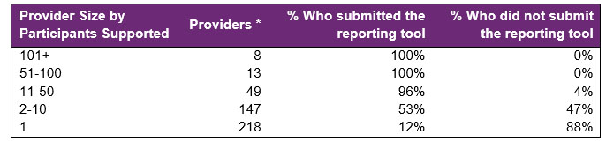There are 435 providers delivering school leaver employment support across the country, with 21 providers delivering to 50 or more participants. 49 providers deliver service to between 11 to 50 participants and 365 deliver supports to less than 10.
The largest 21 providers deliver support to 49% of participants.
Across all providers, data was submitted for 78% of participants with providers who have less than 10 participants having poor return rates. This will be a priority for the Agency to pursue with small providers.
* The provider universe are those identified in the NDIA claimant data for April to June 2022. We are unable to provide this data retrospectively but will include it in all future releases of the report.

Participant count
Figure 2. Participants represented in reporting

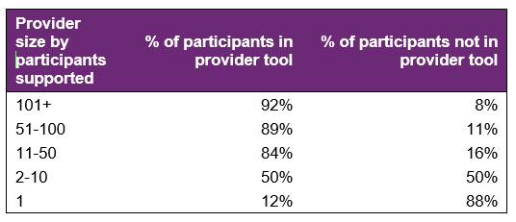
22% of participants who received school leaver employment supports in the last quarter were not represented in the reporting submitted by providers. The Agency is investigating potential reasons for this.

Participant demographics

Employment support recipients

Figure 3. Number of participants

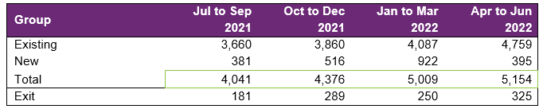
The number of participants receiving employment supports reported by the Provider Reporting Tool (the Tool) is increasing over time.
Notes
- Existing: started employment support before the period
- New: started employment support in the period
- Exit: exits employment support in the period

The above numbers are from the Provider Reporting Tool data that Providers submit to the NDIA quarterly. If in the data supplied, a participant exits employment support in one period (counted in "Exit" numbers above), and a few periods later reenters employment support, the participant will be counted in the "New" numbers again.

Location

Figure 4. State or Territory of residence – number of participants

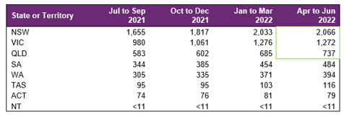

The majority of employment support recipients were in NSW (40%), followed by V I C (25%), and QLD (14%). For comparison, the top 3 states for all NDIS participants aged 15 to 24 are NSW (31%), V I C (24%) and QLD (20%). The over representation in NSW is partly due to the earlier roll out to full scheme in that state and the influence of the legacy NSW Transition to Work program which involved transition teachers in helping students to consider post school options and connected many with employment providers.

Primary disability

Figure 5. Primary disability – number of participants
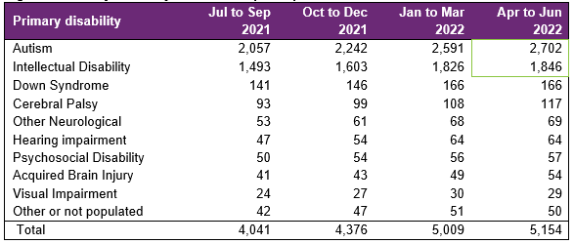
The top primary disabilities experienced by participants utilising these supports were autism (52%), followed by intellectual disability (36%). For comparison, 54% and 28% of all NDIS participants aged 15 to 24 experience autism and intellectual disability, respectively.

Age

Figure 6. Age – percentage of participants
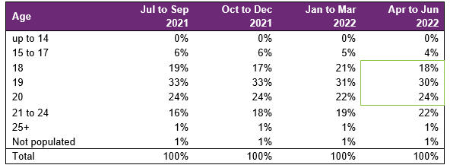
Participants aged 18 to 20 accounted for 72% of employment support recipients. Recipients aged 21 to 24 has grown in proportion.

Gender

Figure 7. Gender – percentage of participants
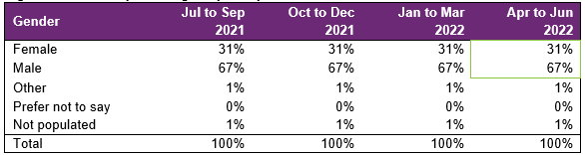
In the most recent period, employment support recipients were 31% female and 67% male. In comparison to all NDIS participants aged 15 to 24, 34% were female and 64% were male. This is in line with the high proportion of employment supports recipients experiencing autism as the primary disability, as the majority of participants who experience autism are males.

Aboriginal or Torres Strait Islander Status

Figure 8. Aboriginal and Torres Strait Islanders – percentage of participants
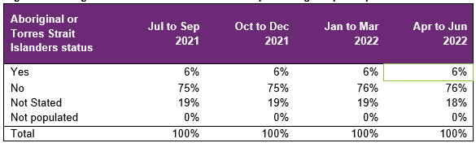
In the most recent period, 6% of employment support recipients identified as Aboriginal or Torres Strait Islander people. This is slightly lower than the 8% of all NDIS participants aged 15 to 24 who identified as Aboriginal or Torres Strait Islander.

Culturally and Linguistically Diverse status

Figure 9. Culturally and linguistically diverse – percentage of participants
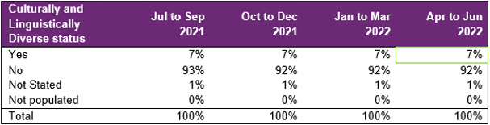

In the most recent period, around 7% of employment support recipients identified as being from a Culturally and Linguistically Diverse community. This is slightly higher than the 6% of all NDIS participants aged 15 to 24 who identified as being from a Culturally and Linguistically Diverse community.

Supports & milestones

Support type hours

Figure 10. Support type provided – percentage of hours per participant
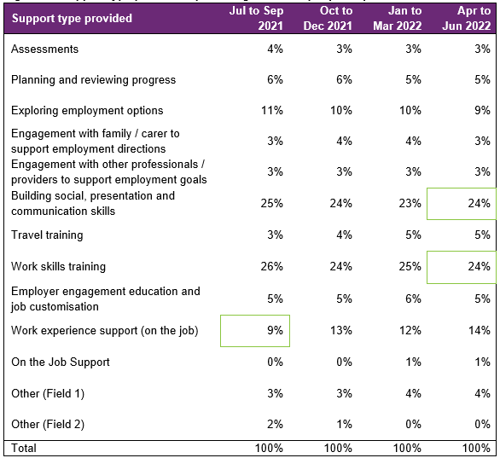

The low percentage of work experience (support on the job) in July to September 2021 coincided with the COVID 19 Delta variant outbreaks and lockdowns (mainly in NSW and
V I C), which has since rebounded. Almost half of the training time was spent building the participant’s social, presentation, communication, and work skills. From a separate analysis (NDIS Outcomes Framework Employment Deep Dive 31 December 2020), gaining work experience was also listed as one of the top supports participants think will help them get a job.

Support delivery method

Figure 11. Delivery method – percentage of hours
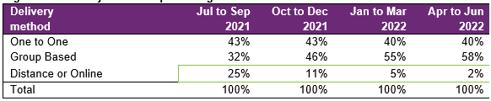
The large percentage of distance or online learning in July to September 2021 coincided with the COVID 19 Delta variant outbreaks and lockdowns (mainly in NSW and V I C). This had reversed in October to December 2021 and continued to drop through to the latest quarter.

Note: Participants have been excluded from this section where the sum of One to One, Group based, Distance or Online percentages did not equal 100%.

Progress towards milestones – snapshot at each reporting period

This section looks at the distribution of progress for participants who worked on a particular milestone (where there are training hours reported for that specific skill), for each reporting period in isolation (non-cumulative).

To assist in interpretation of data, comments below each table summarise progress in the final quarter reported. Comments below each chart describe trends across the different quarters.

Social, presentation and communication skill

Figure 12. Social, presentation and communication skill milestone – percentage of participant progress
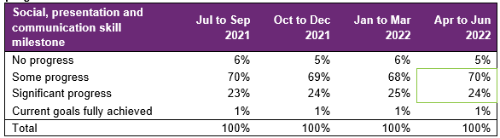
For participants who worked on this specific milestone, 70% reported some progress and almost a quarter reported significant progress. The distribution has been consistent over time.

Travel skill

Figure 13. Travel skill milestone – percentage of participant progress

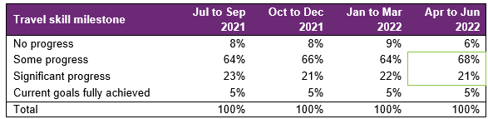
For participants who worked on this specific milestone, 68% reported some progress and 21% reported significant progress. The distribution has been consistent over time.

Work skill

Figure 14. Work skill milestone – percentage of participant progress

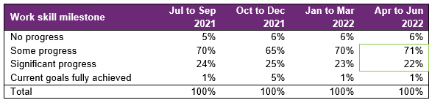
For participants who worked on this specific milestone, 71% reported some progress and 22% reported significant progress.

There was an increase in the percentage of participants fully achieving the work skill goal in the October to December 2021 quarter, potentially coinciding with the end of an annual training program.

Employer engagement, education, and job customization

Figure 15. Employer engagement, education, and job customisation milestone – percentage of participant progress

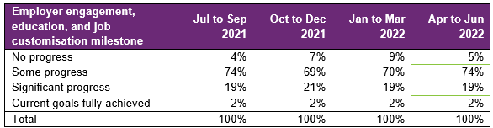

Providers who reported activities as “engaging with employers, educating and customising jobs” for participants reported that 74% made some progress and 19% made significant progress.

The percentage of participants showing some progress reduced following the July to September 2021 quarter. This has since rebounded in the latest April to June 2022 quarter. The percentage of participants showing significant progress or have current goals fully achieved has been fairly consistent over all quarters.

Work experience

Figure 16. Work experience milestone – percentage of participant progress

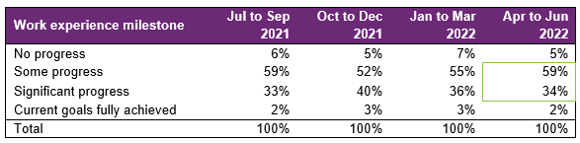

Of the participants engaging in work experience in the most recent quarter, 59% were reported as making some progress, and 34% were reported as making significant progress.

Of those who engaged in work experience, there was an increase in those who achieved significant progress in the October to December 2021 quarter. This may be a natural variation given that many school leavers commence with a provider at the beginning of a calendar year and initially work on other skills prior to commencing work experience. As work experience is strongly associated with achieving an employment outcome, NDIA will carefully monitor support provided and progress achieved against this milestone.

Progress towards milestones – cumulative for the year

The following sections show that more time receiving supports or training is associated with better progress towards mastering specific skills. For each participant, the best progress (across 4 quarters) towards mastering the specific skills is used for this analysis, and compared against the cumulative time receiving employment supports, and training for the specific skills.

Appendix 1 includes more detail on the methodology used in this section.

Social, presentation and communication skill

Figure 17. Social, presentation and communication skill milestone – percentage of participant progress

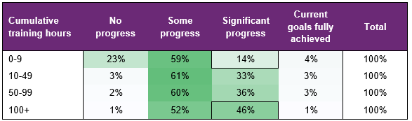
Participants who had received up to 9 hours of training on social, presentation, and communication skills only had a 14% chance of making significant progress towards mastering these skills. This chance increased to 46% after 100+ hours of the skill specific training.

Figure 18. Travel skill milestone – percentage of participant progress

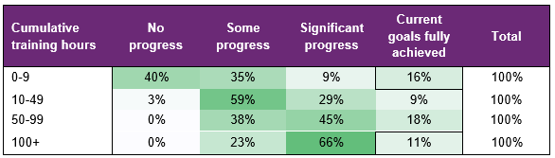
The fact that 16% fully achieved their goal with 0 to 9 hours of training but 11% required 100+ hours of training is an illustration of how individualised the support needs to be (for some participants travel skills may be a primary area of focus).

Work skill

Figure 19. Work skill milestone – percentage of participant progress

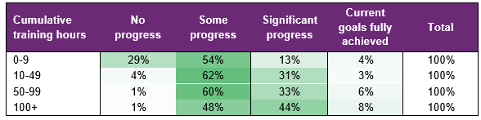
Significant progress was achieved through more cumulative hours of training in work skills, illustrating how individually tailored the support needs to be.

Employer engagement, education, and job customization

Figure 20. Employer engagement, education, and job customisation milestone – percentage of participant progress
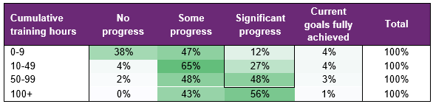

The chance of making significant progress towards employer engagement, education, and job customisation milestones increased markedly up to 100 hours of training.

Work experience

Figure 21. Work experience milestone – percentage of participant progress
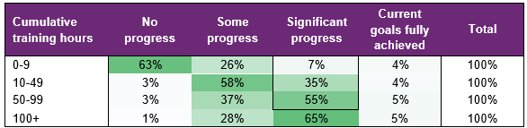

The chance of making significant progress towards work experience milestones increased markedly up to 100 hours of training.

Final outcomes

This section shows the distribution of outcomes upon exiting employment support (based on the employment support reported end/exit date).

Figure 22. Final outcomes (upon exiting employment support) – number of participants.

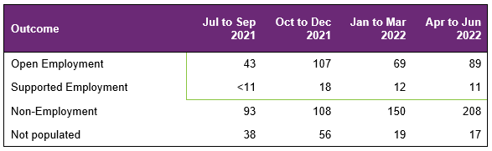
The number of participants finishing employment supports with open or supported employment was lower in July to September 2021 and January to March 2022, which coincided with the COVID 19 Delta (mainly in NSW and V I C) and Omicron variant outbreaks and lockdowns, respectively. Both quarters were followed by subsequent rebounds in the number of participants in October to December 2021 and April to June 2022, coinciding with the end of lockdowns.

From July 2021 to June 2022, 356 participants finished employment support with open or supported employment.

Figure 23. Final outcomes (upon exiting employment support) – percentage of participants.

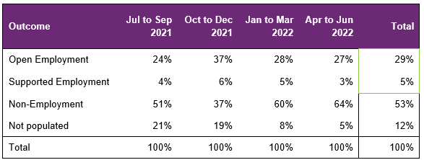
The percentage finishing with open or supported employment was lower in July to September, which coincided with the COVID 19 Delta variant outbreaks and lockdowns (mainly in NSW and V I C). This was followed by a rebound in October to December, coinciding with the end of lockdowns. However, the percentage of participants decreased again in the following January to March 2022 and April to June 2022 quarter.

From July 2021 to June 2022, 34% of participants finished employment support with open or supported employment.

The following table provides a more granular breakdown of outcomes for participants who exited employment supports from July 2021 to June 2022.

Figure 24. Final outcomes breakdown – percentage and total number of participants:

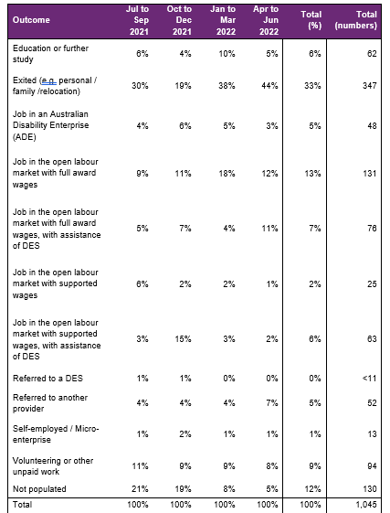The absolute numbers (nonpercentages) have been shown as a total only in the above table (not broken down into individual quarters) due to low volume in the individual quarter. Individual quarter absolute numbers will be shown once there is sufficient volume.

For participants whose final outcome is Exited (e.g. personal / family /relocation) the common reasons reported were:
- personal or family circumstances,
- relocated,
- school leaver employment supports funding ended,
- not engaging or contactable and,
- transferred to Disability Employment Services or another provider.

Open employment outcomes comprise of:
- jobs in the open labour market, with full award or supported wages, with or without the assistance of Disability Employment Services (D E S)
- or Self-employment/Micro-enterprise.

A job in an Australian Disability Enterprise (A D E) is classified as Supported Employment. The other categories in the chart above are classified as nonemployment outcomes.

Final employment outcomes

Employment type

Figure 25. Employment type – number of participants

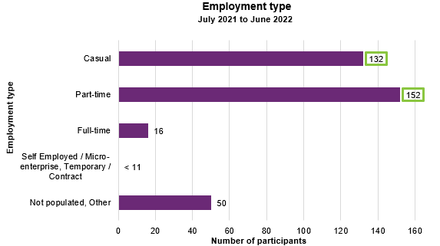

From July 2021 to June 2022, of participants who finished employment support with paid employment, 132 gained casual work while 152 gained part-time work.

Figure 26. Employment type – percentage of participants

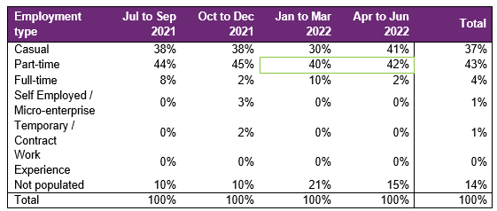
The percentage of participants finishing with parttime employment decreased in the January to March 2022 quarter. This percentage has shown a small increase in the April to June 2022 quarter.
From July 2021 to June 2022, of participants who finished employment support with paid employment, 37% gained casual work while 43% gained part-time work.

Hours worked

Figure 27. Hours worked per week – percentage of participants
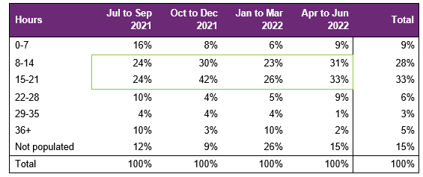

The percentage of participants working between 8 to 21 hours per week was lowest in July to September 2021 and January to March 2022, which coincided with the COVID 19 Delta (mainly in NSW and V I C) and Omicron variant outbreaks and lockdowns, respectively. Both quarters were followed by subsequent rebounds in October to December 2021 and April to June 2022, coinciding with the end of lockdowns.

From July 2021 to June 2022, of participants who finished employment support with paid employment, 70% worked up to 21 hours per week.

Industry of employment

Figure 28. Industry of employment – percentage of participants

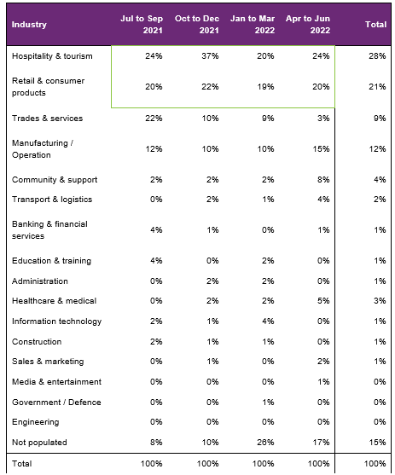
The percentage of participants who worked in Hospitality, Tourism, and Retail was lowest in July to September 2021 and January to March 2022, which coincided with the COVID 19 Delta (mainly in NSW and V I C) and Omicron variant outbreaks and lockdowns, respectively. Both quarters were followed by subsequent rebounds in October to December 2021 and April to June 2022, coinciding with the end of lockdowns.

From July 2021 to June 2022, of participants who finished employment support with paid employment, 69% work in Hospitality, Tourism, Retail, Trades, Manufacturing, or Operation.

NDIS supports in employment

Figure 29. Will the participant be utilising NDIS supports in employment? – number of participants

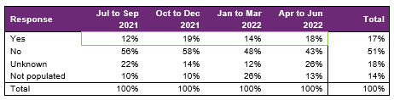
The percentage of participants that will be utilising NDIS supports in employment has been increasing, however was lowest in July to September 2021 and saw a decrease in January to March 2022. These quarters coincided with the COVID 19 Delta (mainly in NSW and V I C) and Omicron variant outbreaks and lockdowns, respectively. Both quarters were followed by subsequent rebounds in October to December 2021 and April to June 2022.

From July 2021 to June 2022, providers reported 17% of participants who finished employment support with paid employment will be using NDIS supports in employment to maintain their employment.

Supported wages

Figure 30. Will the employer use supported wages for the participant's employment? – percentage of participants

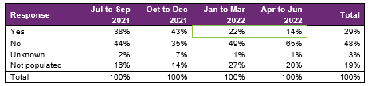
Of participants who finished employment support with paid employment, the percentage of employers that will use supported wages for the participant’s employment has decreased in the last two quarters.

From July 2021 to June 2022, providers reported that employers will use supported wages for 29% of participants who finished employment support with paid employment.

Intermediate employment outcomes

This section contains the employment features for all of the participants who commenced employment from July 2021 to June 2022. The participants may or may not have exited employment support. Participants with Employment Type "Work Experience" are excluded.

Employment outcomes (July 2021 to June 2022)
695 participants started in paid employment
43% of participants worked between 15 and 36 hours

The top 4 industries in which participants started employment were Retail, Hospitality/Tourism, Trades/Services and Manufacturing/Operations.

Employment type

Figure 31. Employment type – number of participants

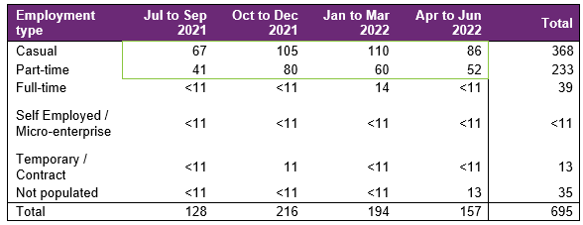
The number of participants finishing with casual and part-time employment was lowest in July to September 2021, which coincided with the COVID 19 Delta variant outbreaks and lockdowns (mainly in NSW and V I C). This rebounded in the following two quarters, however, has decreased in the April to June 2022 quarter.

A total of 695 participants were reported to have commenced employment from July 2021 to June 2022. During this period, 368 started casual work while 233 started part time work.

Figure 32. Employment type – percentage of participants

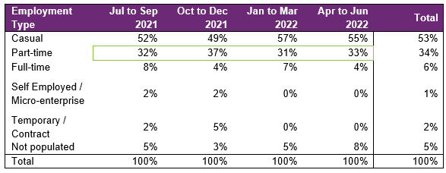
The percentage of participants who started part-time work was lowest in July to September 2021 and January to March 2022. These quarters coincided with the COVID 19 Delta (mainly in NSW and V I C) and Omicron variant outbreaks and lockdowns, respectively. Both quarters were followed by subsequent rebounds in October to December 2021 and April to June 2022.

From July 2021 to June 2022, of participants who started employment, 53% started casual work, while 34% started part-time work.

Hours worked

Figure 33. Hours worked per week – percentage of participants

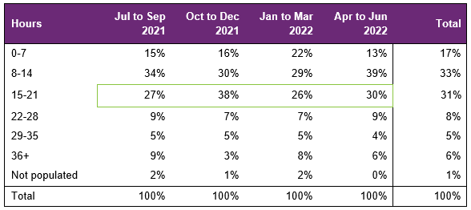
The percentage of those working 15 to 21 hours was lowest in July to September 2021 and January to March 2022, coinciding with the COVID 19 Delta (mainly in NSW and V I C) and Omicron variant outbreaks and lockdowns, respectively. Both quarters were followed by subsequent rebounds in October to December 2021 and April to June 2022.

From July 2021 to June 2022, of participants who started employment, 80% worked up to 21 hours per week.

Industry of employment

Figure 34. Industry of employment – percentage of participants

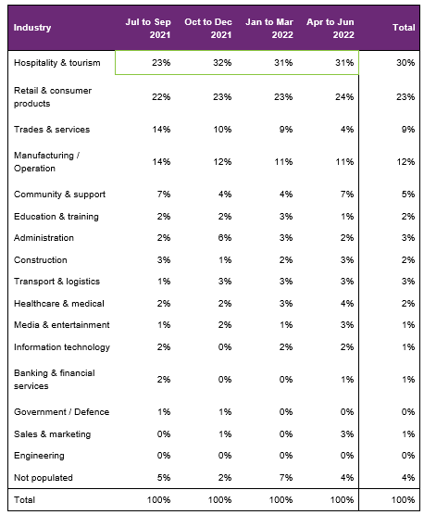
The percentage who worked in hospitality and tourism was lowest in July to September 2021, coinciding with the COVID 19 Delta variant outbreaks and lockdowns (mainly in NSW and V I C). This percentage saw an increase in the following quarter, coinciding with the easing of COVID 19 restrictions and the opening of international borders, and had been steady since.
From July 2021 to June 2022, of participants who started employment, 74% worked in Hospitality, Tourism, Retail, Trades, Manufacturing or Operation.

NDIS supports in employment

Figure 35. Will the participant be utilising NDIS supports in employment? – percentage of participants

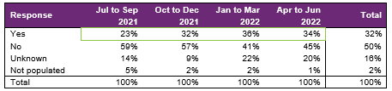
From July 2021 to June 2022, of participants who started employment, providers report 32% will be using NDIS supports in employment to maintain their employment.

This percentage has been generally increasing since the July to September 2021 quarter, with a small reduction in the most recent April to June 2022 quarter.

Supported wages

Figure 36. Will the employer use supported wages for the participant's employment? – percentage of participants

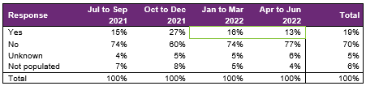
This percentage has seen a decreasing pattern in the last two quarters.

From July 2021 to June 2022, providers report employers will use supported wages for 19% of the participants who started employment.

Model summary

Modelling approach
A model was built to predict successful employment outcomes, defined as any of the following:
- Job in the open labour market, with full award or supported wages, with or without the assistance of Disability Employment Services
- Self-employed / Micro-enterprise
- Supported employment.
The modelling dataset is sourced from the Provider Reporting Tool and NDIA’s own participant data, with the former containing outcomes and support hours and the latter containing characteristics such as Culturally and Linguistically Diverse Status and education activities.
Using 3 statistical techniques, we determine the significant predictors of employment success. Ranked in order from the most to least important the significant predictors are:
- Progress made towards achieving employer engagement and job customisation milestone.
- Progress made towards achieving work skills milestones.
- Progress made towards achieving work experience support milestones.
- Whether a participant is assisted to get a job
- Hours spent in achieving employer engagement and job customisation milestones.
A Generalised Linear Model was then constructed using the above significant variables.
Appendix 2 has more details on the accuracy of the model.

What helps (or hinders) finding paid employment
Figure 37. Variables that help or hinder finding paid employment
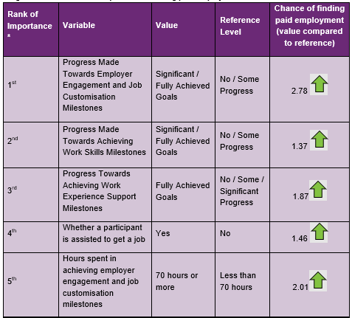
* 1st = most predictive
How to interpret the above table:
- Participants who made significant progress towards or fully achieved their employer engagement, education, and job customisation milestones were 2.78 times as likely to find employment compared to participants who made no or some progress towards similar milestones.
Participants who are assisted to get a job are 1.46 as likely to find employment compared to participants who were not assisted to get a job.

Differences in modelling insights between reporting period ending Q4 (December) 2021 and Q2 (June) 2022

The following table summarises the differences in significant variables selected in Q4 (December 2021) and Q2 (June) 2022.

Figure 38. Differences in modelling insights (Q4 2021 and Q2 2022)

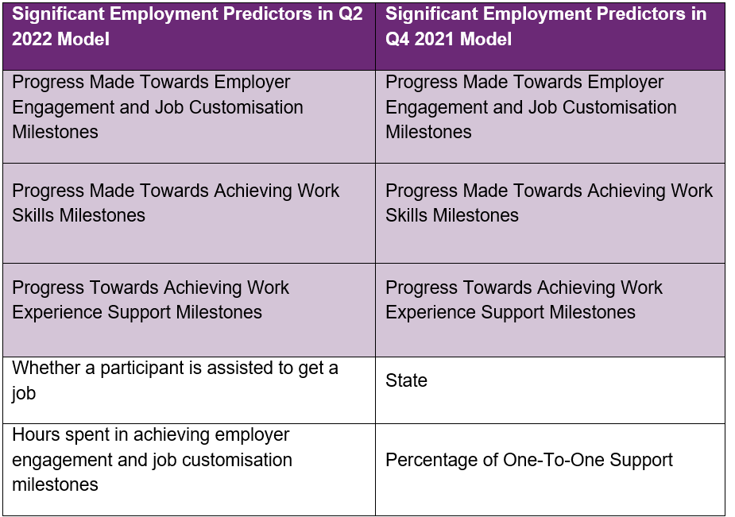

The differences in modelling insights are caused by the following:

- Different modelling universe. The modelling insights from Q4 2021 data are based on the outcomes of all participants regardless of whether they have exited the support, while the modelling insights from Q2 2022 data are strictly based on the outcomes of participants who have exited the support.

- Different number of observations. The modelling insights from Q2 2022 data are based of 936 observations, which is less than the 1309 observations used to model the Q4 2021 data. Lower number of observations affects the 95% confidence interval of each predictor (i.e., confidence that the mean response for each predictor variable will fall within a specified range), which affects the significance of each predictor.

In summary, differences in modeling insights are caused by different modelling universe.

Appendix

Appendix 1 – Methodology for the section titled “Progress towards milestones – cumulative for the year”
This Appendix provides more details on how to interpret the section titled “Progress towards milestones – cumulative for the year,” and the methodology used.
How to interpret the table below
Work experience milestone – percentage of participant progress
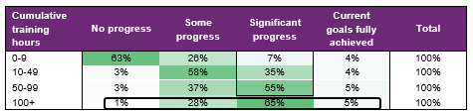
Out of all participants who have received 100+ hours of on the job work experience support (cumulative for the year)
- 1% have No progress as the best result for the year.
- 28% have Some progress as the best result for the year.
- 65% have Significant progress as the best result for the year.
- 5% have Current goals fully achieved as the best result for the year.
The sum of each row in the above table equals 100%.
Methodology (for cumulative training hours)
The starting universe is all participants reported in the Provider Reporting Tool across the 4 quarters. For each participant, the cumulative training hours is then calculated as the total of the milestone specific training hours reported in the Provider Tool for the 4 quarters. The best progress for the specific milestone is used (of all progress entries reported in the Provider Reporting Tool across the 4 quarters).
For example, if for participant John Smith, below are the progresses and hours reported across the 4 quarters.

Work experience support (on the job)
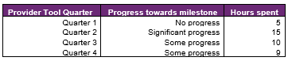
Cumulative training hours = 39 = 5 + 15 + 10 + 9 and the progress selected for John is Significant progress (the best progress of the 4 quarters). The cumulative training hours is then rounded down to the nearest whole number (e.g., 6.75 is rounded down to 6), and grouped into bands. Then for each cumulative training hours group (e.g., 0 to 9), the percentage of participants in each (best) progress category is calculated so that the sum of the row is 100%.

Appendix 2 – Model accuracy

The generalised linear model presented in Section 7 has the following accuracy:
Figure 39. Model accuracy – Gini and AUC
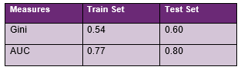
The closer the test set AUC and Gini is to 1, the better the model performance.
Test set AUC (and Gini) is larger than training set AUC (and Gini) since the number of observations in the test set is quite small (311) relative to the training set (936).
Figure 40. Model accuracy – receiver operating curve
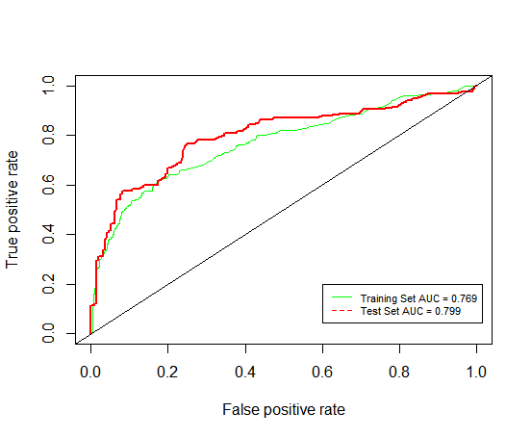

Figure 41. Model accuracy – actual versus predicted
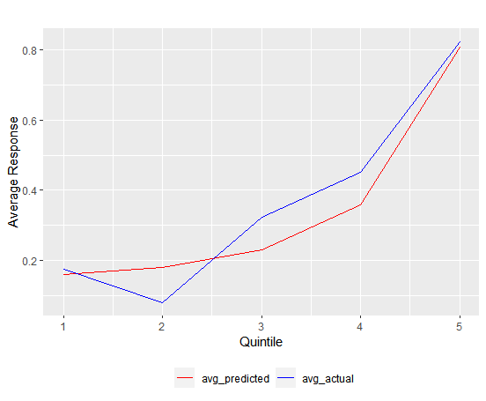
The model predicted probability, red curve is close to the actual outcome, blue curve, indicating that the model is able to closely predict the probability of recipients finding paid employment.

